Firas Aboushamalah

250-920-750

Assignment #3

Question 1 & 2

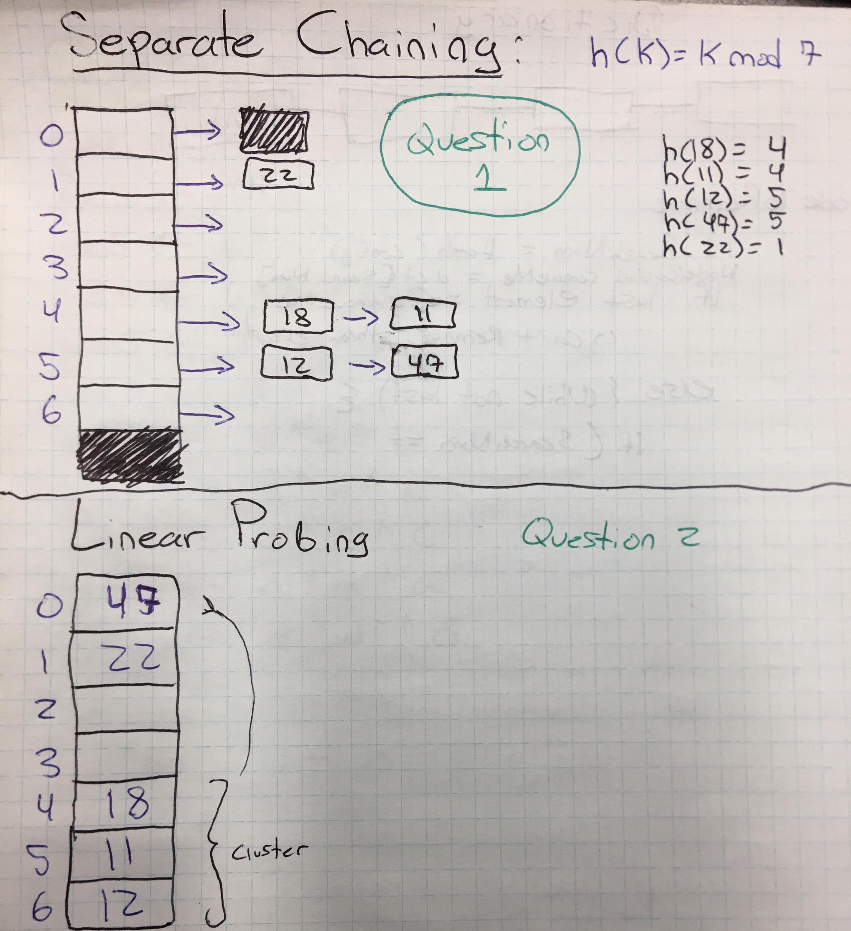

Question 3:

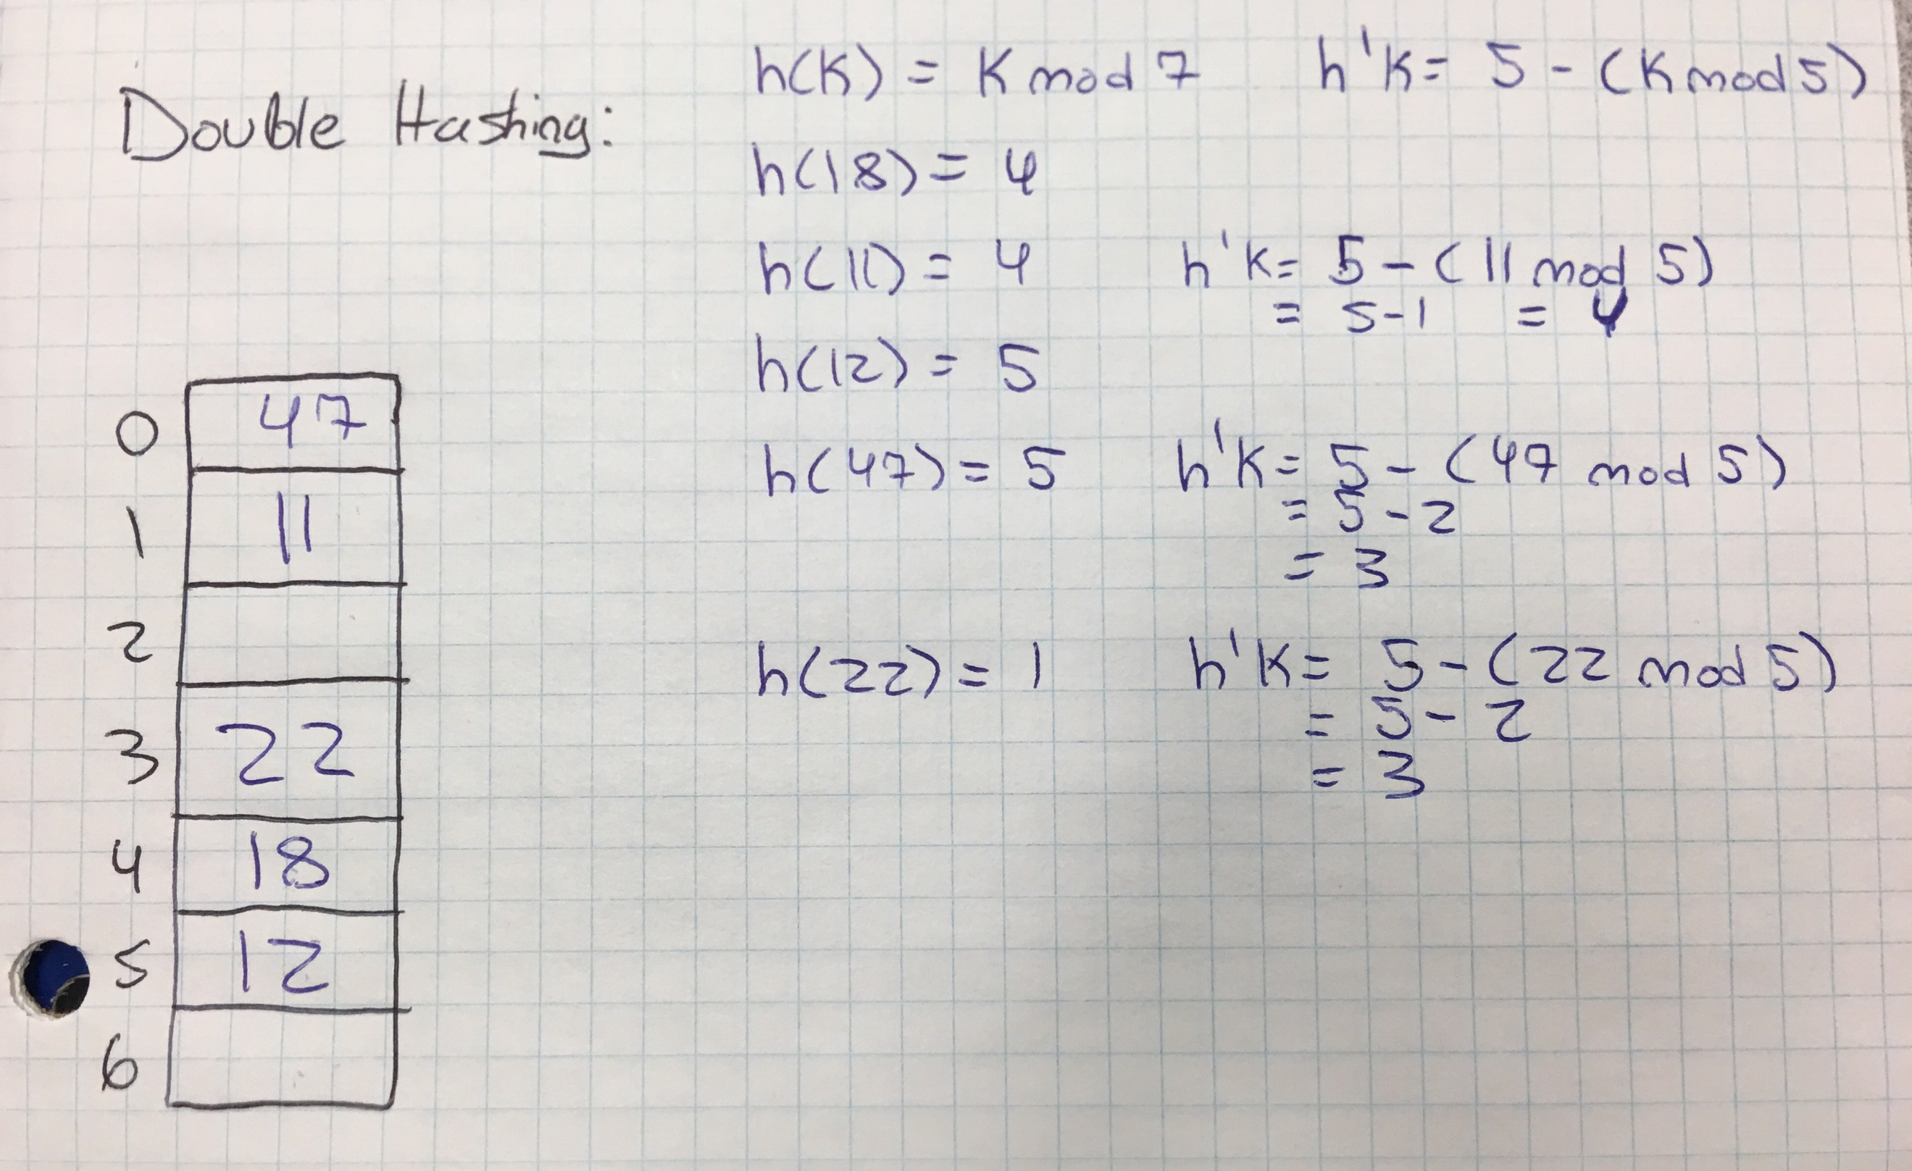

Question 4:

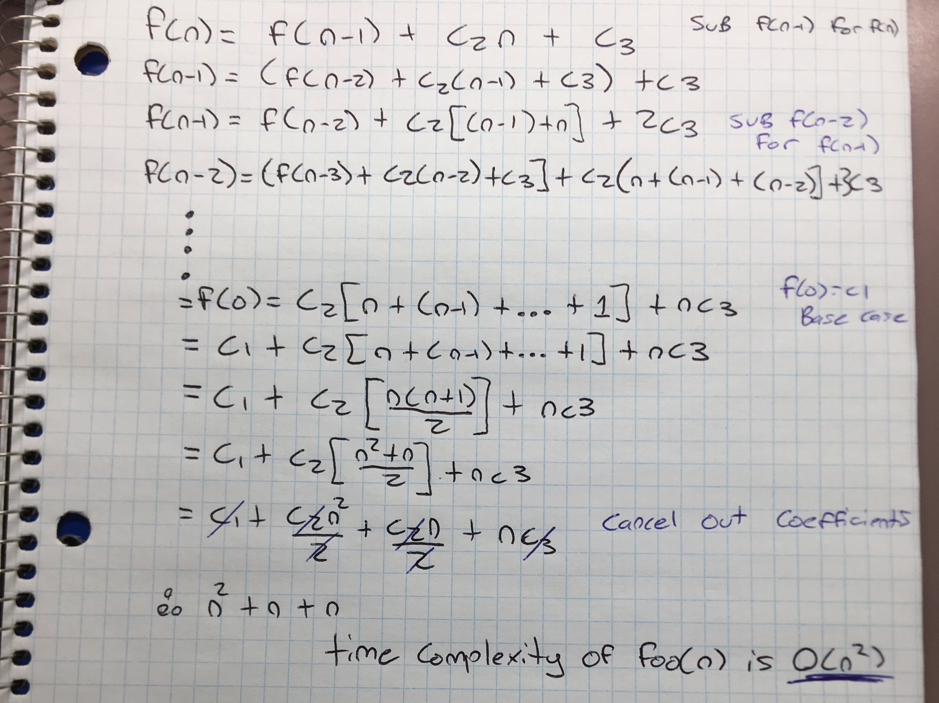

Question 5i:

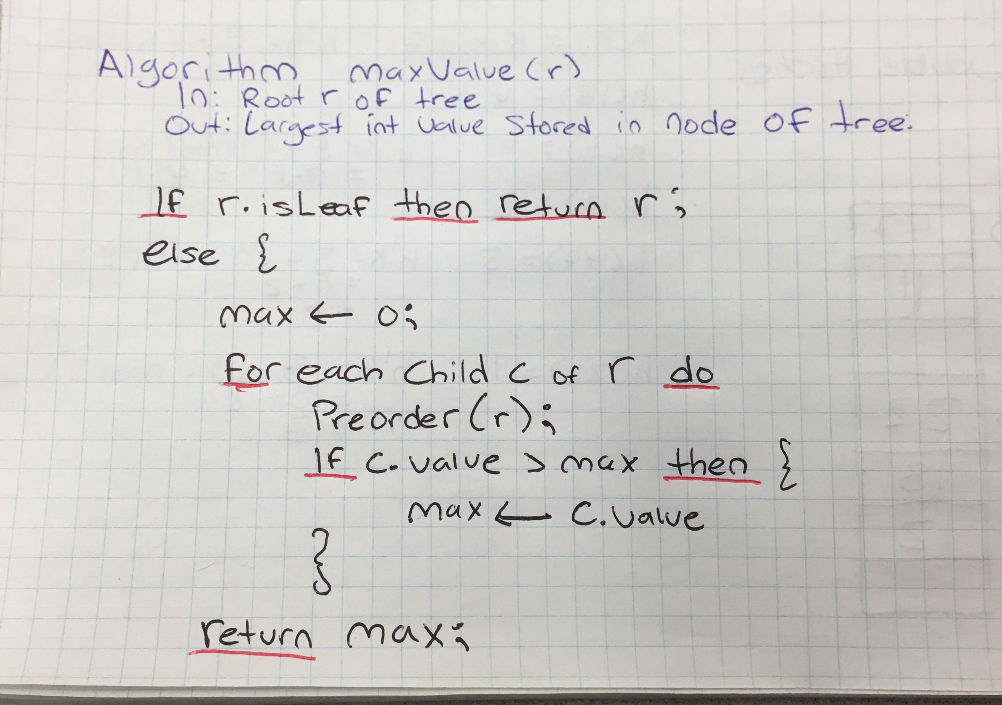

Question 5ii:

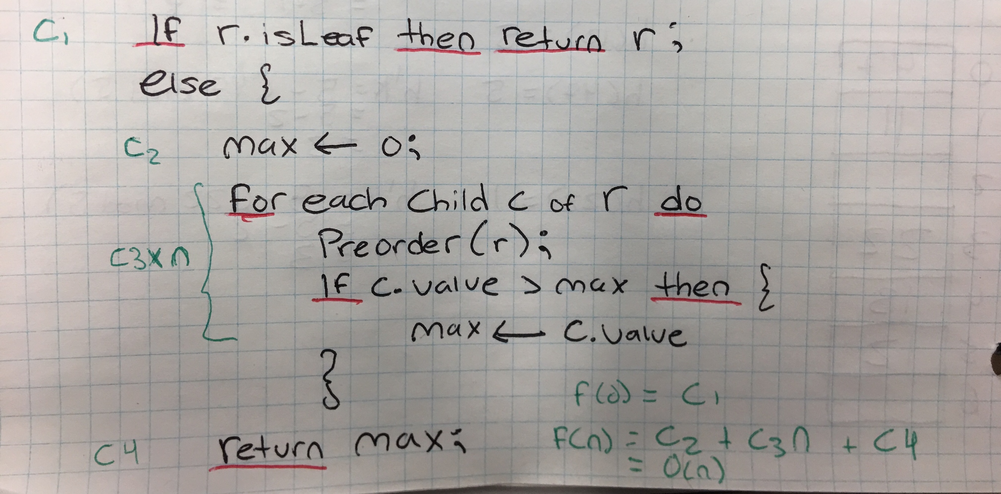

Add up the constants for size n = 0 and the algorithm ends at first line so f(0) = c1

For size n, the algorithm has 2 constants and a 3 constant multiplied by n iterations via “*preorder(r)”*

Therefore, the time complexity of this algorithm is O(n) for n > 0